Susquehanna Workforce Innovation Partnership (SWIP) Quarterly Meeting
August 14, 2018 • 2 p.m. – 4 p.m.
Hosted by Cecil College at Elkton Station

Introductions:
The meeting kicked off with introductions and participants were asked to identify one thing that is new or has changed in their work environment.

Attendees:
- Alyssa Bonser (DORS), Miles Dean (Cecil College), Debra Stevens (Cecil College), Cora Grishkot (HCDSS), Clara Henry (SWN-UC), Sandi Johnson (HCDSS), Bruce England (SWN), Dorothea Phillips (Cecil DSS), Judy Potter-Brown (Wage Connection), Linda Siegel (SWN), Carolyn Fletcher (Cecil), Sharon Miller (DLLR), Mischelle Williams (Cecil DSS), Nicole Parr (CCPS), Colleen Flewelling (Cecil College), Pam Karwowski (HCC), Gwen Haney (SSA-i)
- SWIP Facilitators were Joan Michel and Sandy Cormack

Susquehanna Workforce System: Reflection and Discussion
- Workforce System Roles: Because of numerous comments about lack of commonality in missions among partners, the facilitators wanted to give partners an opportunity to identify their role in the workforce system and explore overlaps with other agencies. A graphic was used to describe each level of impact from the individual to the global and we discussed the organizations’ roles. See below.
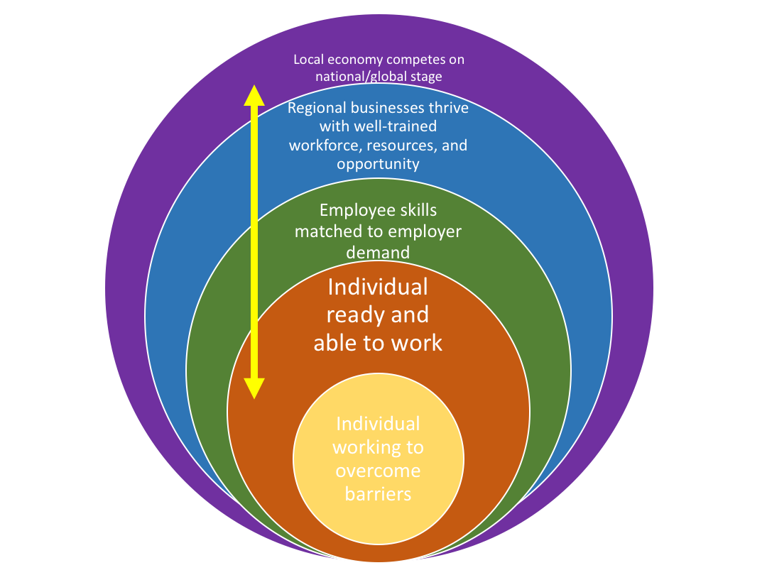
- Areas of integration: We then discussed potential areas of integration for the workforce system, for instance in training – places where training doesn’t exist and places where multiple trainings on the same topic are taking place. Where can cost savings occur because of integration among agencies? Where can more seamless service be provided? What opportunities are in front of us?
- Comments from the May-July 2018 survey were examined. We discussed barriers that arose and prioritized them as actionable or not, and assessed the priority of each barrier as an issue to address as a system. Among all barriers identified, those deemed both actionable and a priority are listed below.
    - Data Sharing
      - A hindrance is that data is hard or impossible to share on clients that we serve. So many rules on confidentiality and we all have different requirements. Jump through a lot of hoops just to have a conversation about a particular client. If we had ability to confidentially and prudently share relevant info with partners, this would go a long way.
    - Partner Tunnel Vision
      - Everyone is focused on own mission. Hard to step outside that. How do we work together to accomplish goal while staying within our program guidelines, which don’t always match. Priorities are different and so vast among partners. Competing goals.
      - Everyone has their own mission. How do we work together to accomplish goal while staying within our program guidelines, which don’t always match? Priorities are different and so vast among partners. We have competing goals.
    - Partner Lateral Communication/Situational Awareness
      - Are we actually working together? Are we really getting calls from folks who need services? Are our partners aware enough to know how to refer people?
      - Re-entry: access to bonding program. Trying to make bonding program easier to access
    - Self-esteem

Goals and action plan for FY2019
SWIP reviewed and revised the draft Action Plan for FY2019. The Action plan was organized in alignment with the Maryland State Benchmarks, which has five strategic goals. SWIP chose three Action Steps to focus on during the first half of FY2019. These are:
- Create training opportunities to fill identified gaps and explore opportunities for integrated training
- Define a common referral process for all SWIP organizations to implement
- Develop methods for lateral communication and situational awareness about other agencies, such as cross-training, organizational profiles, web site.

The SWIP Plan for FY2019 is included in this document as an appendix. At the February meeting, SWIP will choose three additional Action Steps to work during the second half of FY2019.

We identified several co-leads for each initiative and identified two more to invite (who were not at the meeting). Sandy and Joan will support the co-leads to organize people and work to accomplish the action step in coming weeks. We will check-in on progress at the November meeting.

WIOApartners.com Website
Joan introduced the WIOApartners.com website to SWIP and had a brief discussion about its use and place as a communication tool. It will be further developed by Joan and the group focused on improving lateral communication.

Meeting agendas, minutes, and related material can be found by clicking on the meeting event on the calendar. For instance, you can access these minutes and slides at http://wioapartners.com/event/swip-quarterly-meeting/ and other meeting notes at wioapartners.com/events.

Next Meeting
The next SWIP meeting will be held on November 13, 2-4 p.m., at Harford Community College. The Room number will be sent out closer to the event. Watch this space: http://wioapartners.com/event/swip-quarterly-meeting-2/

Susquehanna Action Plan for FY2019
WIOA Vision: Increased access and opportunities to employment, education, training, and support services to employment
SWIP Mission: Susquehanna Workforce Innovation Partnership provides Susquehanna job seekers an individualized suite of support services, so they possess skills for businesses and enterprises to compete in the local, regional, and global economies.

Strategic Goal 1 | FY19 Action Steps/Milestones | Task Leads
Increase earning capacity of Maryland’s workforce system customers by maximizing access to employment | Create pathways for warehouse and construction careers | Sandy
Strategic Goal 2: | FY19 Action Steps/Milestones | Lead
Increase earning capacity of Maryland’s workforce system customers by maximizing access to and use of skills and credentialing
Strategic Goal 3: | FY19 Action Steps/Milestones | Lead
Increase earning capacity of Maryland’s workforce system customers by maximizing access to and use of life management skills | Create training opportunities to fill identified gaps and explore opportunities for integrated training | Bruce England and HCC
Strategic Goal 4: | FY19 Action Steps/Milestones | Leads
Increase earning capacity of Maryland’s workforce system customers by eliminating barriers to employment | Ensure that any new training initiative focuses on soft skills and self-esteem as a barrier to employment | Bruce England and HCC
 | Explore issue of transportation and expanding options for employees and job seekers | Joan
Strategic Goal 5: | FY19 Action Steps/Milestones | Leads
Strengthen and enhance the effectiveness and efficiency of Maryland’s workforce system | Define a common referral process for all SWIP organizations to implement | Miles Dean and Carolyn Fletcher
 | Develop methods for lateral communication and situational awareness about other agencies, such as cross-training, organizational profiles, web site. | Gwen Haney and co-lead

